

**Higher Diploma in Mechanical &**

**Electrical Engineering**

Module Name:

Electrical Power Systems

Student Name:

KAMAIYA DHARMARAJ

Student ID:

HDMEEJan23-3

Lecturer Name:

Ragesh

**QUESTION 1**

1. What is capacitor

A capacitor is a two-terminal electrical device that can store energy in the form of an electric charge. It consists of two electrical conductors that are separated by a distance.  The space between the conductors may be filled by vacuum or with an insulating material known as a dielectric. The ability of the capacitor to store charges is known as capacitance.

Capacitors store energy by holding apart pairs of opposite charges. The simplest design for a capacitor is a parallel plate, which consists of two metal plates with a gap between them. But, different types of capacitors are manufactured in many forms, styles, lengths, girths, and materials.

Let us consider the most basic structure of a capacitor – the parallel plate capacitor. It consists of two parallel plates separated by a dielectric. When we connect a DC voltage source across the capacitor, one plate is connected to the positive end (plate I) and the other to the negative end (plate II). When the potential of the battery is applied across the capacitor, plate I become positive with respect to plate II. The current tries to flow through the capacitor at the steady-state condition from its positive plate to its negative plate. But it cannot flow due to the separation of the plates with an insulating material.

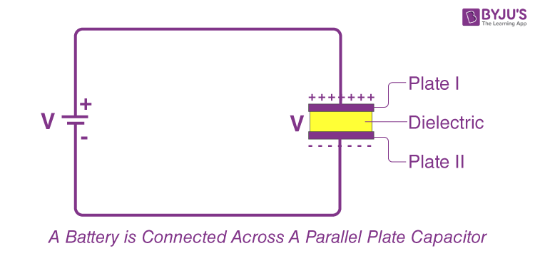

An electric field appears across the capacitor. The positive plate (plate I) accumulates positive charges from the battery, and the negative plate (plate II) accumulates negative charges from the battery. After a point, the capacitor holds the maximum amount of charge as per its capacitance with respect to this voltage. This time span is called the charging time of the capacitor.

When the battery is removed from the capacitor, the two plates hold a negative and positive charge for a certain time. Thus, the capacitor acts as a source of electrical energy.

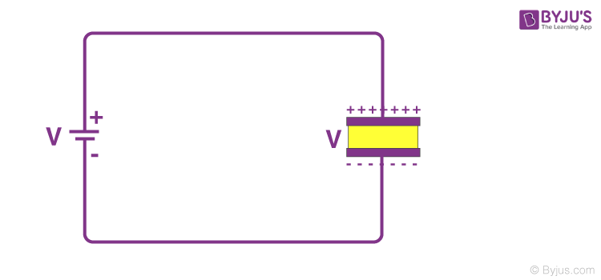

If these plates are connected to a load, the current flows to the load from Plate I to Plate II until all the charges are dissipated from both plates. This time span is known as the discharging time of the capacitor.

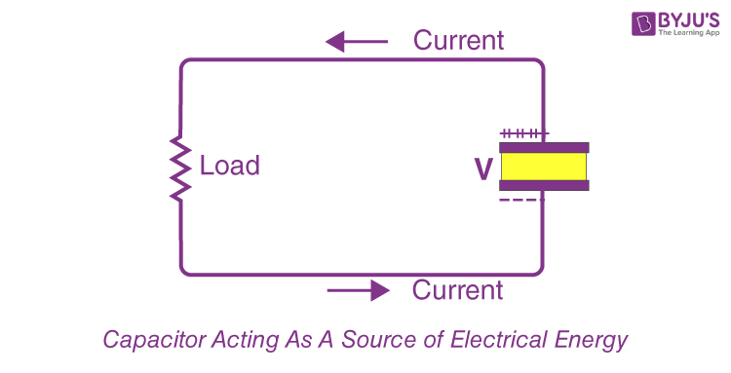

b) A capacitor is constructed from two conductive metal plates 30cm x 50cm which are spaced 6mm apart from each other, and uses dry air as its only dielectric material. Calculate the capacitance of the capacitor.

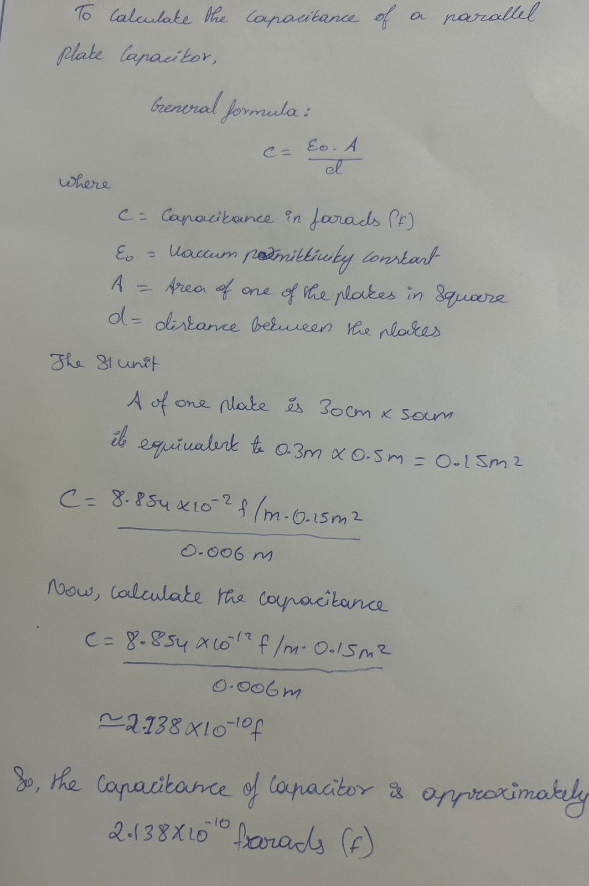

Question 2

a) What is capacitive reactance. Explain with the help of formula

Capacitive Reactance is the measurement of a capacitor’s resistance to alternating current. It is known that a capacitor is defined as a device that stores current and has the ability to influence the amount of charging it can achieve. The value of its capacitance is determined by the frequency f of the electrical signal travelling through it. It is the resistance of a circuit element to changes in current or voltage. Its standard unit of measurement ohms (Ω). It is represented by the symbol Xc and its dimensional formula is given by [M1L2T-3I-2]. Its mathematical formula is equal to unity divided by twice the product of pi, frequency and the capacitance of a capacitor.

A capacitor is a device used to store electrical energy. The capacitance of a capacitor determines the amount of charging a capacitor can achieve. The measure of the opposition to alternating current by the capacitor is called Capacitive Reactance. The unit of Capacitive Reactance is Ohms like resistance. The symbol of Capacitive Reactance is Xc.

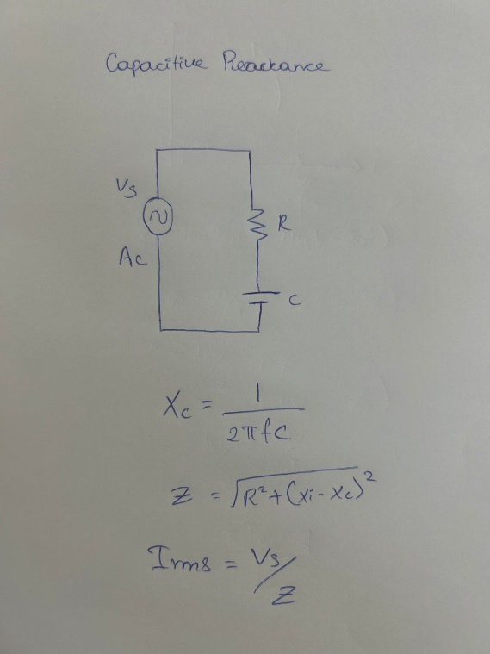

b) Derive the formula of total capacitance, when the three capacitors are connected in parallel

When capacitors are connected in parallel, their total capacitance (C total) can be found by simply adding up the individual capacitances (C1,C2,C3,etc.) of the capacitors. Mathematically, it can be expressed as:

C total =C 1 +C 2 +C 3 +…

So, if you have three capacitors(C1,C2,C3)connected in parallel, the total capacitance (C total ) is:

C total=C 1+C 2 +C 3

​

This formula holds true for any number of capacitors connected in parallel. The total capacitance in a parallel combination is simply the sum of the individual capacitances.

When capacitors are connected in parallel, they share the same voltage across their terminals, but the total capacitance is increased. This is useful in applications where you want to increase the overall capacitance in a circuit.

Here are a few key points and considerations when capacitors are connected in parallel:

Additive Capacitance: As mentioned earlier, the total capacitance (C total) in a parallel combination is the sum of the individual capacitances (C1,C2,C3,…).

C total =C1+C2+C3+…

Voltage: All capacitors in parallel have the same voltage (V) across them. This is because they are connected directly across the same voltage source or circuit.

Equivalent Capacitance: When you have more than two capacitors in parallel, you can find their equivalent capacitance (C eq) using the formula mentioned above. The equivalent capacitance simplifies the circuit analysis.

C eq =C1+C2+C3+…

Charging and Discharging: When connected in parallel, capacitors will charge and discharge independently based on the voltage across them, but they will share the same voltage source.

Energy Storage: The total energy stored in a parallel combination of capacitors is the sum of the energies stored in each capacitor. The energy stored in a capacitor is given by U= 1/2CV, where U is the energy, C is the capacitance, and

V is the voltage.

Time Constants: The time constant for the charging or discharging of each capacitor depends on its individual resistance (if any) and capacitance. Capacitors with larger capacitance values will take longer to charge or discharge if the resistance in the circuit is significant.

Applications: Parallel capacitors are used in various electronic circuits to increase the energy storage capacity, stabilize voltage levels, and filter out noise or ripple in power supplies.

Capacitors in parallel refer to the capacitors that are connected together in parallel when the connection of both of its terminals takes place to each terminal of another capacitor. Furthermore, the voltage's ( Vc ) connected across all the capacitors, whose connection in parallel, is the same.

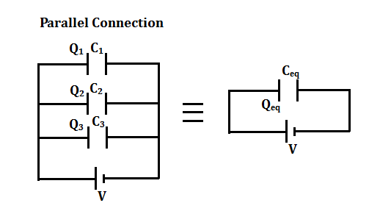

Question 3

a) In the following circuit, the supply voltage is defined as: V(t) = 325 sin (314t – 30o) and L= 2.2H. Determine the value of the current flowing through the coil and draw the resulting phasor diagram

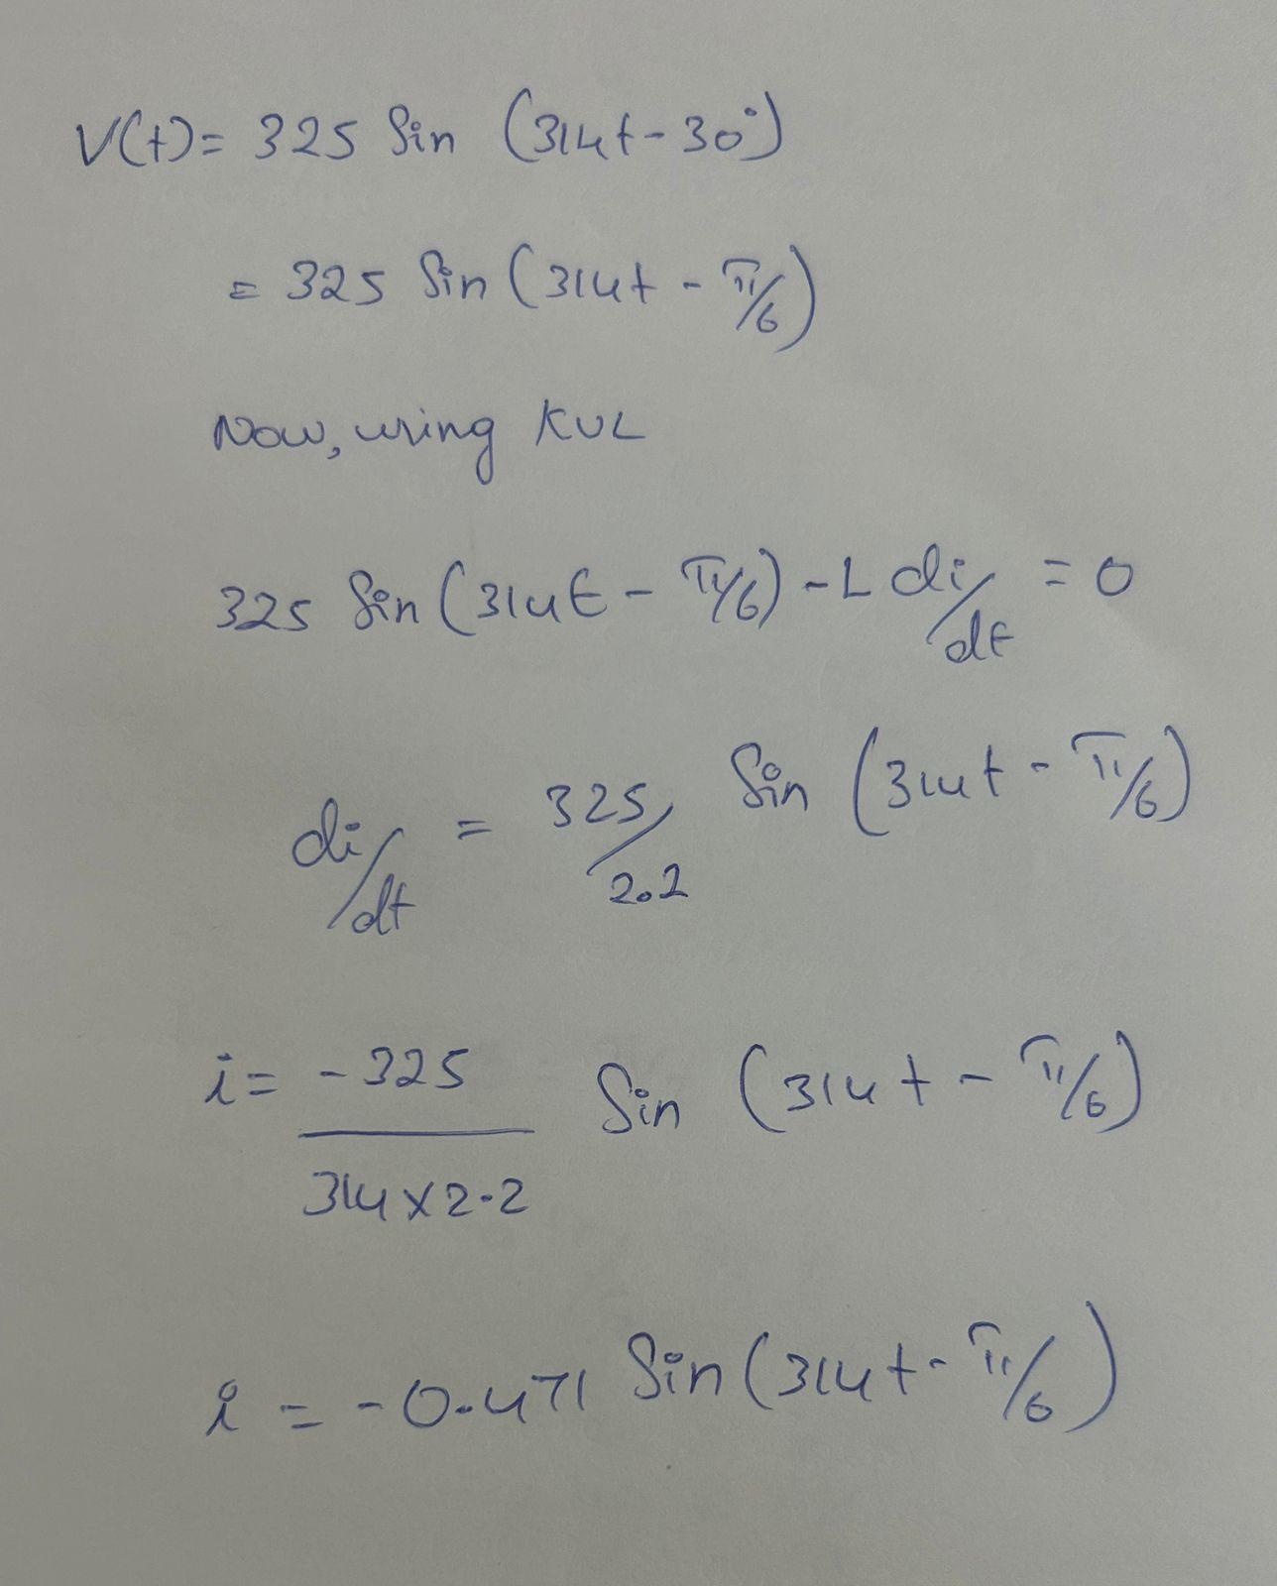

b) A single-phase sinusoidal AC supply voltage defined as: V(t) = 240 sin (314t – 20o) is connected to a pure AC capacitance of 200uF. Determine the value of the current flowing into the capacitor and draw the resulting phasor diagram.

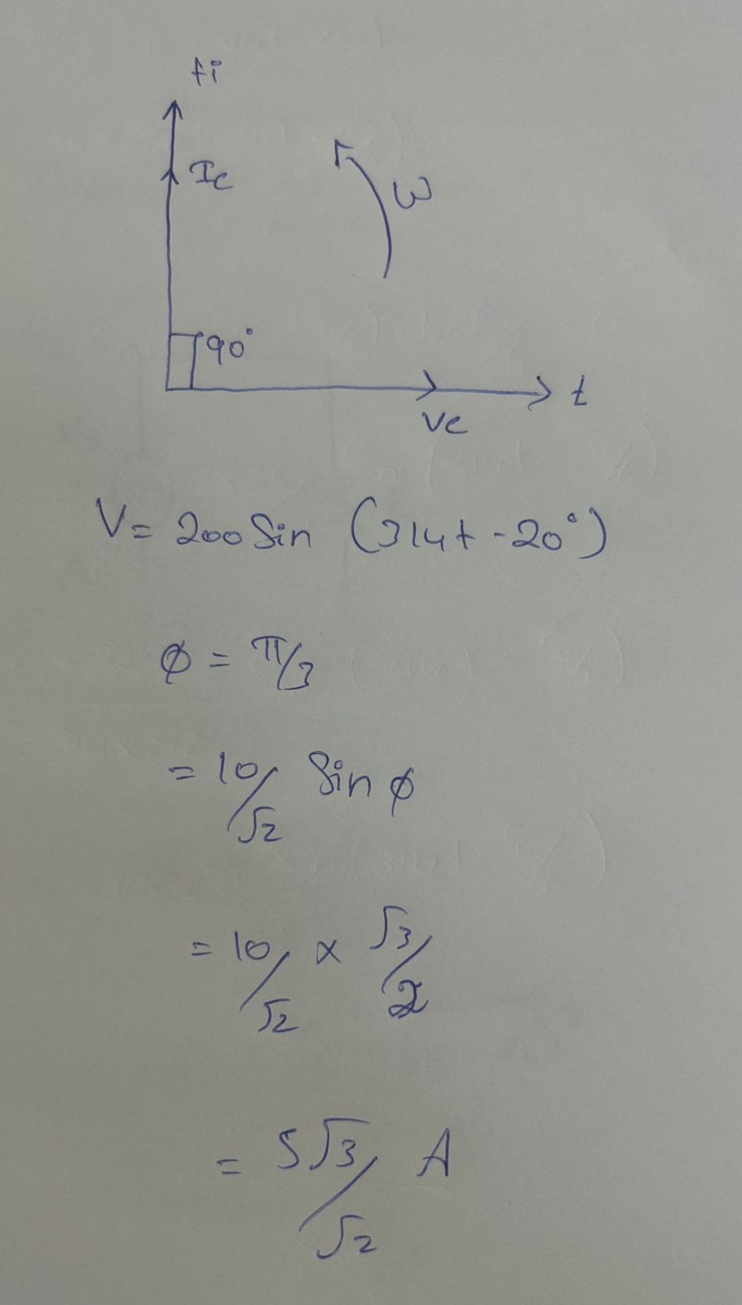

Question 4

Please explain the process of power generation in Thermal power plant and Hydel power plant. Also, discus the advantages and disadvantages

Thermal Power Plant

A thermal power plant is a power plant where heat energy is transformed into electric power. In most of the world, the turbine is steam-driven. Water is heated, converts into steam and rotates a turbine which drives an electric generator. After it passes through the turbine, the steam is condensed back into water and returned to the boiler.

Thermal power stations are usually considered reliable sources of electricity, however, they can be subject to sudden outages if the coal supply fails.

Thermal energy is the energy that is transferred by heating or cooling a substance. This type of energy can be found in many different places, such as the sun, the Earth’s core, and even in people. Thermal energy is used for many different purposes, such as heating homes and generating electricity. Thermal energy is converted into mechanical energy in the turbine, which is then used to generate electricity in the generator.

Advantages of Thermal Power Plants

The use of thermal power plants has proved to be a milestone for the modern world. With rapid industrialization happening in and around the world, thermal power has been put to good use. So, we have listed some of the advantages of thermal power plants below.

1.They are cost-effective.

2.They require less amount to set it up as compared to other power plants.

3.A huge amount of power is generated.

4.Thermal power plants are a reliable source of energy to handle future power demands.

5.The technology for thermal power generation is well-established and easily accessible.

6.The cost of fuel in generating electricity through these plants is less as compared to gas.

Disadvantages of Thermal Power Plant

Thermal Power plants have been a game changer for modern society. However, one has to bear the huge cost of maintenance, and the efficiency of machines to name a few. The disadvantages of using thermal power plants in India are as follows:

1.As these plants require the use of exhaustible resources, therefore, it can cause the depletion of these fossil fuels.

2.The cost of maintaining and operating the plant is high as the machines and equipment in them require skilled people to handle them efficiently.

3.A high volume of water is needed to produce steam that can drive the turbines to produce electricity.

4.The overall efficiency of thermal plants is low. Several coal-based thermal plants use outdated technology that lacks the chance of upgradation.

Hydel power plant

Let's try to understand what is hydropower plant. When water is at a height, it has potential energy stored in it. When this water flows down, its potential energy is first converted to kinetic energy and then to mechanical energy with the help of turbines. With the use of a generator, the mechanical energy is transformed into electrical energy. Hydropower is essential only next to thermal power. Hydropower plants meet nearly 20% of the total power of the world.

Generally, the hydroelectric power plants are installed in hilly areas where dams can be built and large water reservoirs can be obtained. In a hydroelectric power plant, the water head is created by constructing a dam across a river. From the dam, water is led to a water turbine. The water turbine converts the hydraulic energy of the falling water into mechanical energy. The turbine drives the alternator, which converts the mechanical energy of the turbine into electrical energy.

Advantages of Hydroelectric Energy

1. Electricity can be produced at a constant rate once the dam is constructed

2. The gates of the dam can be shut down if electricity is not needed, which stops electricity generation. Hence by doing this, we can save water for further use in future when the demand for electricity is high.

3. One of the biggest advantages of hydroelectric power plants is that they are designed to last many decades, and so they can contribute to the generation of electricity for years.

4. Large dams often become tourist attractions because the lake that forms in the reservoir area behind the dam can be used for leisure or water sports.

5. The water from the lake of the dam can be used for irrigation purposes in farming.

Disadvantages of Hydroelectric Energy

1. It is not an easy task to assemble a hydropower plant because the dams are extremely expensive to build, and they require extremely high standards and calculations for their construction.

2. It becomes important that the hydropower plant must serve for many decades because of its high cost of construction, and this totally depends on the availability of water resources.

3. If flooding happens due to natural calamities or the failure of dams, it would impact a large area of land, which means that the natural environment can be destroyed.

4. People are forcibly removed from the particular area where a hydropower plant is going to be assembled. This affects the day-to-day life of people living in that area.

5. A serious geological damage can be caused due to the construction of large dams.

Question 5

What are the different types of transmission Lines

A transmission Line is used by electrical power systems to transfer electricity between any two distant points. In terms of electrical engineering, the Transmission Line is a set of conductors that is designed to transfer the power from the generating station to a far-end substation that is located near the load centers, in the most efficient and secure way.

The transmission line is generally made up of ACSR (aluminum conductor steel reinforced) type conductors, the steel is used to improve the mechanical strength of the conductor. The majority of strands in the ACSR conductor are made up of aluminum as it is a good conductor of electricity and its weight per unit length is less compared to copper. In this article, we will discuss the classification of transmission lines, transmission line parameters, and modeling.

Transmission lines carry electric energy from one point to another in an electric power system. They can carry alternating current or direct current or a system can be a combination of both. Also, electric current can be carried by either overhead or underground lines. The main characteristics that distinguish transmission lines from distribution lines are that they are operated at relatively high voltages, they transmit large quantities of power and they transmit the power over large distances.

The types of transmission lines are:

1.Overhead Transmission Lines

2.Subtransmission Lines

3.Underground Transmission Lines

1.Overhead Transmission Lines

Overhead AC transmission lines share one characteristic; they carry 3-phase current. The voltages vary according to the particular grid system they belong to. Transmission voltages vary from 69 kv up to 765 kv. The following are examples of different overhead transmission line structures in use today. The DC voltage transmission tower has lines in pairs rather than in threes (for 3-phase current) as in AC voltage lines. One line is the positive current line and the other is the negative current line.

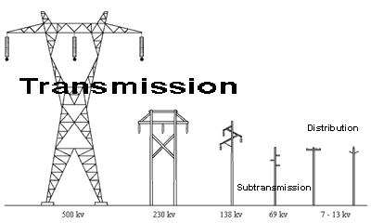

2.Subtransmission Lines

Subtransmission lines carry voltages reduced from the major transmission line system. Typically, 34.5 kv to 69 kv, this power is sent to regional distribution substations. Sometimes the subtransmission voltage is tapped along the way for use in industrial or large commercial operations. Some utilities categorize these as transmission lines.

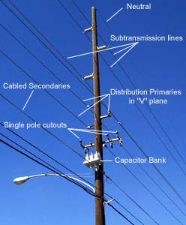

3.Underground Transmission Lines

Underground transmission lines are more common in populated areas. They may be buried with no protection, or placed in conduit, trenches, or tunnels.

